The Believers

By Giorgio Trombatore

On my very first days in Darfur, once I asked to one of my staff members who were according to him the most influential people in Darfur.
He told me :”well the Uali for sure “, then I replied :”of course I know the Uali (which is the Governor) is a powerful man but beside this political figure who has got other influence on the people, rather than politica?”.
He than answered “ok, all right, you mean maybe Tariqa Al Tijani, sheikh Musa, the spiritual leader to whom many Sudanese refer as prominent religious figure”.

That was it. From that moment I wanted to get in touch with this Tariqa Al Tijani and possibly meet their famous Sheikh Musa.
Two years later this conversation I saw the official opening of an Emergency Paediatric Center in Nyala funded by the Italian Community and donated to the Tariqa al Tijani people.

What is this Tariqa ? The problem is that in reality in Darfur many people remain ignorant about specific subjects especially in the country side, but I got my answers from one of the leaders that dwelled in Nyala.
Practically he told me :”it is a path, a way (Tariqa), and a method of studying and putting into practice Islamic Spiritual Science (Tasawwuf). The role of the shaykh is that of a spiritual guide, a teacher who keeps the student ever focused on Allah.”
That was what he told me, and later on I learned that this Tariqa had strong roots in Darfur and highly respected by the people.

From a simple question, to a beautiful health structure in the heart of Darfur, the path is short.

In 2004 I started to visit an area called “Garba Intifada”, a poor suburb on the outskirts of Nyala.
I was brought there by friend, because according to him many believers of Tariqa al Tijani were living there in huts, after fleeing the killing of civilians mainly from West Darfur Region.

In “Garba Intifada” (this is the complete name of the area) I met Sheikh Giuma, a man on his early forties from the Fur tribe that under a makeshift tent was making a sermon. He was a sheikh, a very poor one, dealing with religious matters, and as he presented himself, he said that he was a member of the Tariqa. He told me that he escaped from the interior and found shelter in Nyala.
On my visiting day he affirmed that there were about 1.500 families living there.
From that moment I started with the help of the Italian government to support the families of this group, and most of all I became very familiar with all their clan .

On the eve of Christmas 2004 I was invited by the leader of the Tariqa Al Tijani ,Sheikh Musa , in their Mosque located nearby the hills that surround one part of Nyala.
The Sheikh was coming back from Dubai and having heard that Italians people were helping his community wanted to meet them arranging for them a small dinner inside the library of his mosque.

It was in December 23 that the meeting took place.The weather in Darfur was already cool on this period of the year. I stood in the library of Tariqa Al Tijani , and after being served a cup of hot tea, I waited patiently the arrival of the religious leader.
Sheikh Giuma from Garba Intifada area was keeping me company together with some others believers.We were sitting on the floor, all around religious books , some pictures of Mullah, and many children on the entrance curious to see me in such a place.
From time to time Sheikh Giuma with a whip was chasing them awat.
Giuma and the other believers were all dressed in white with their turban on their head . They were pretty proud of this room, their books, saying to me that Government done nothing for their community, despite Tariqa managed to build a school, a play-ground and a mosque.
When finally Sheikh Musa arrived he was accompanied by five other religious people.
He was an old distinguished man, with a very dignified look like many religious representatives.
He was wearing a brown mantel, had a small white bear, and had on his hands the beads that kept turning throughout all the time that we spoke.
Sheikh Musa spoke gently, told me that millions of African are adepts to the Tariqa Al tijani and that their spiritual leader at the moment is in Nigeria.
He was somehow representative for the Sudan, but travelled constantly between Arab states, Morocco and Libia.
Sheikh Musa regretted the civil war, for him a bigger crime since it is involving Muslims against Muslims. He thanked us for our help, and then after this formalities invited me to join him for dinner.
Every time I was speaking he simply uttered “ Tayeb, Tayeb, very good very good, and seemed very happy that a westerner spoke a broken Arabic language, the language that He a religious leader was very fond of.
We moved in another room.
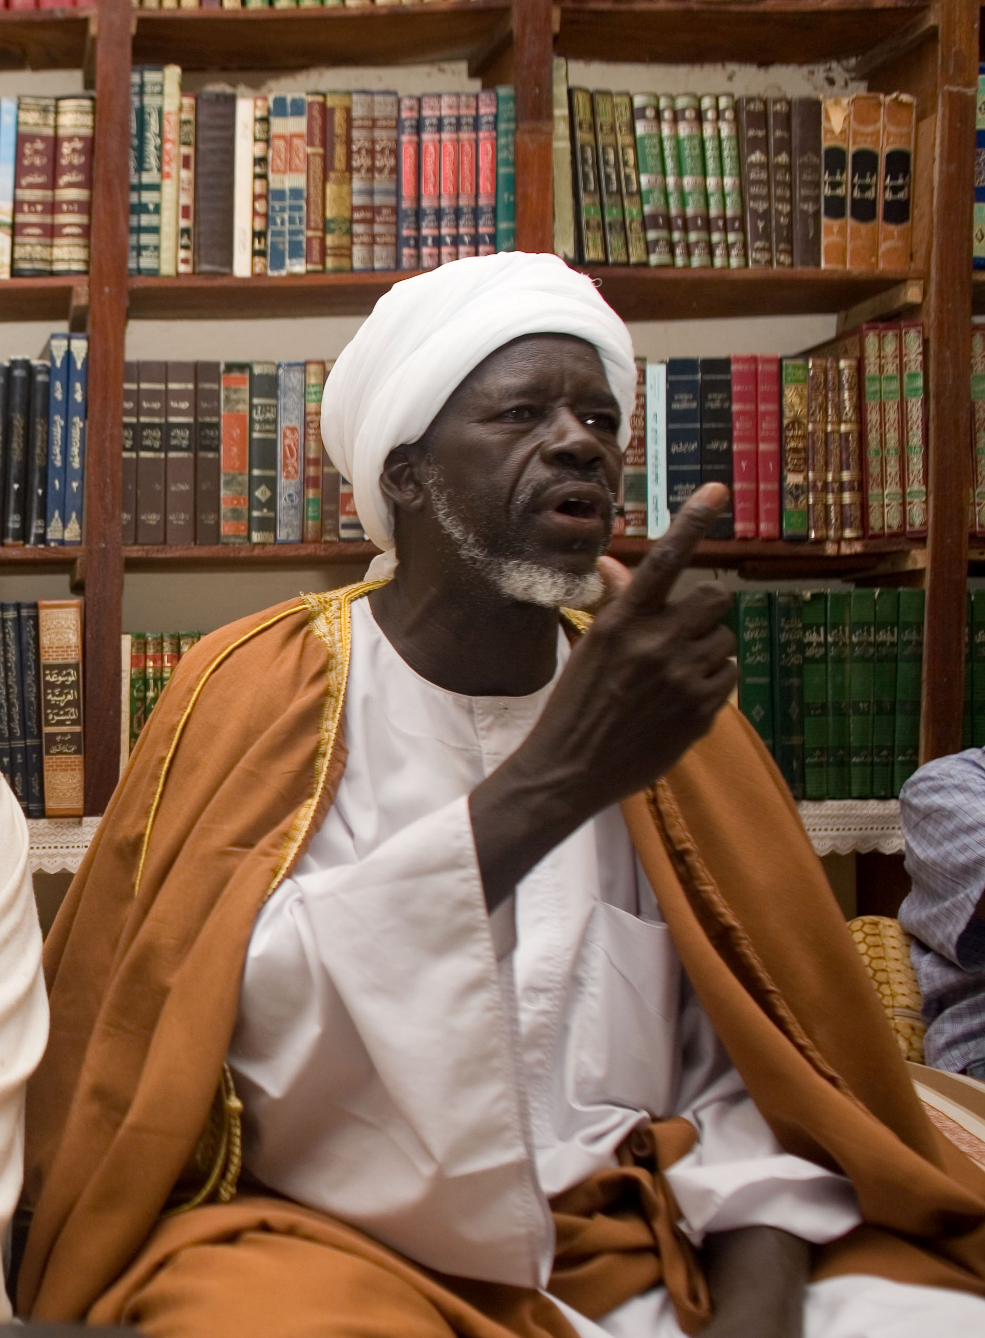
Sheik Musa in Nyala

Two young boys were preparing the dinner .
We ate, drank a lot of tea, then we separated.
Sheik Musa informed me that he had to travel back to Khartoum, but before living reminded us that the health facilities were very poor in his suburb and asked for any kind of help on this matter.

Following the dinner on December 2004, my meetings with the Tariqa Al Tijani leaders become very frequent. I continued to support Garba Intifada with distribution of food , and as well with activities with the local community.
On 2005, following a proposal from the Barbara Contini, special envoy for the Italian Government in Darfrur, we planned to construct a Paediatric Emergency Center in the area of Al jebel (Nyala, Tariqa Al Tijani Suburb).

The news spread so fast, that was immediately also given on local radio agency and local tv. All the religious people of Tariqa rejoiced about the news, because the so called Paediatric Center was meant to give free medical health services for the poor IDPs that camped in sights nearby Nyala.

The event was celebrated in Al Jebel Area not far from the Mosque of Tariqa Al Tijani. The Sheik wanted to celebrate the construction of the hospital giving a big celebration party among the community.
Most of the participants were from Fur tribe , some escaped from the ethnic cleansing of the fighting in West Darfur, others were coming from the area of Jebel Marra fleeing the sufferings under the Sudan Liberation Army poor living condition.
A big “raquba “ ( a sort of a stage) was being staged among the poor huts of Al Jebel, and a local Mullah from the loud-speakers was reading the holy Koran prior the speech of the Sheik.
The Sheik so this a good opportunity to strengthen his hold with the community, in fact the civil war the killings of more than 200.000 mainly from black Muslims tribe affected also the leadership of this religious people that were not able to stop with their sermons one single bullet.

But not all the members of the Tariqa were moved by good spirit like Sheik Musa, in fact soon after the construction of the Hospital was completed , the young doctors from Khartoum who proposed themselves to run the hospital showed their dark side of the charity.
They were only interested in the fees, in matching their salaries with the UN standard careless of the charitable aim of the project.

I had to call again the old Sheik to put an end to the quarrels made up by the young doctors that tried constantly to seek their interests out of this institution.
Sheik Musa kindly accepted our invitation, and one early morning spoke in the dining room of our office in Nyala to the doctors reminding them that all visits were free of charge, all drugs free of charge and that all this was possible thanks to the Italian solidarity.

The speech was useless, the doctors kept on with their attitude regardless that the Institution was giving free service to Tariqa Al Tijani people and poor IDPs. At the end ,we had to change all of them, with a new group that seemed more sensible to the words of Sheik Musa and to the sufferings of the people.

Frankly speaking I was not surprised about the management problem and about the fact the some doctors would have been more attracted by the fact that it was a new building and that being managed by the Italians salary may have been more attractive than government ones.

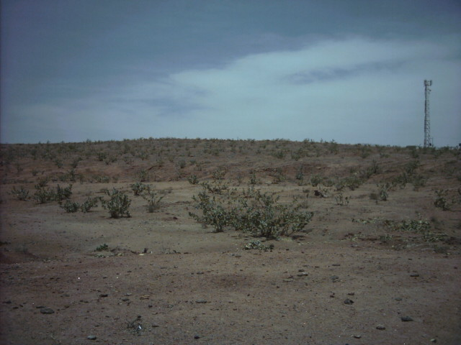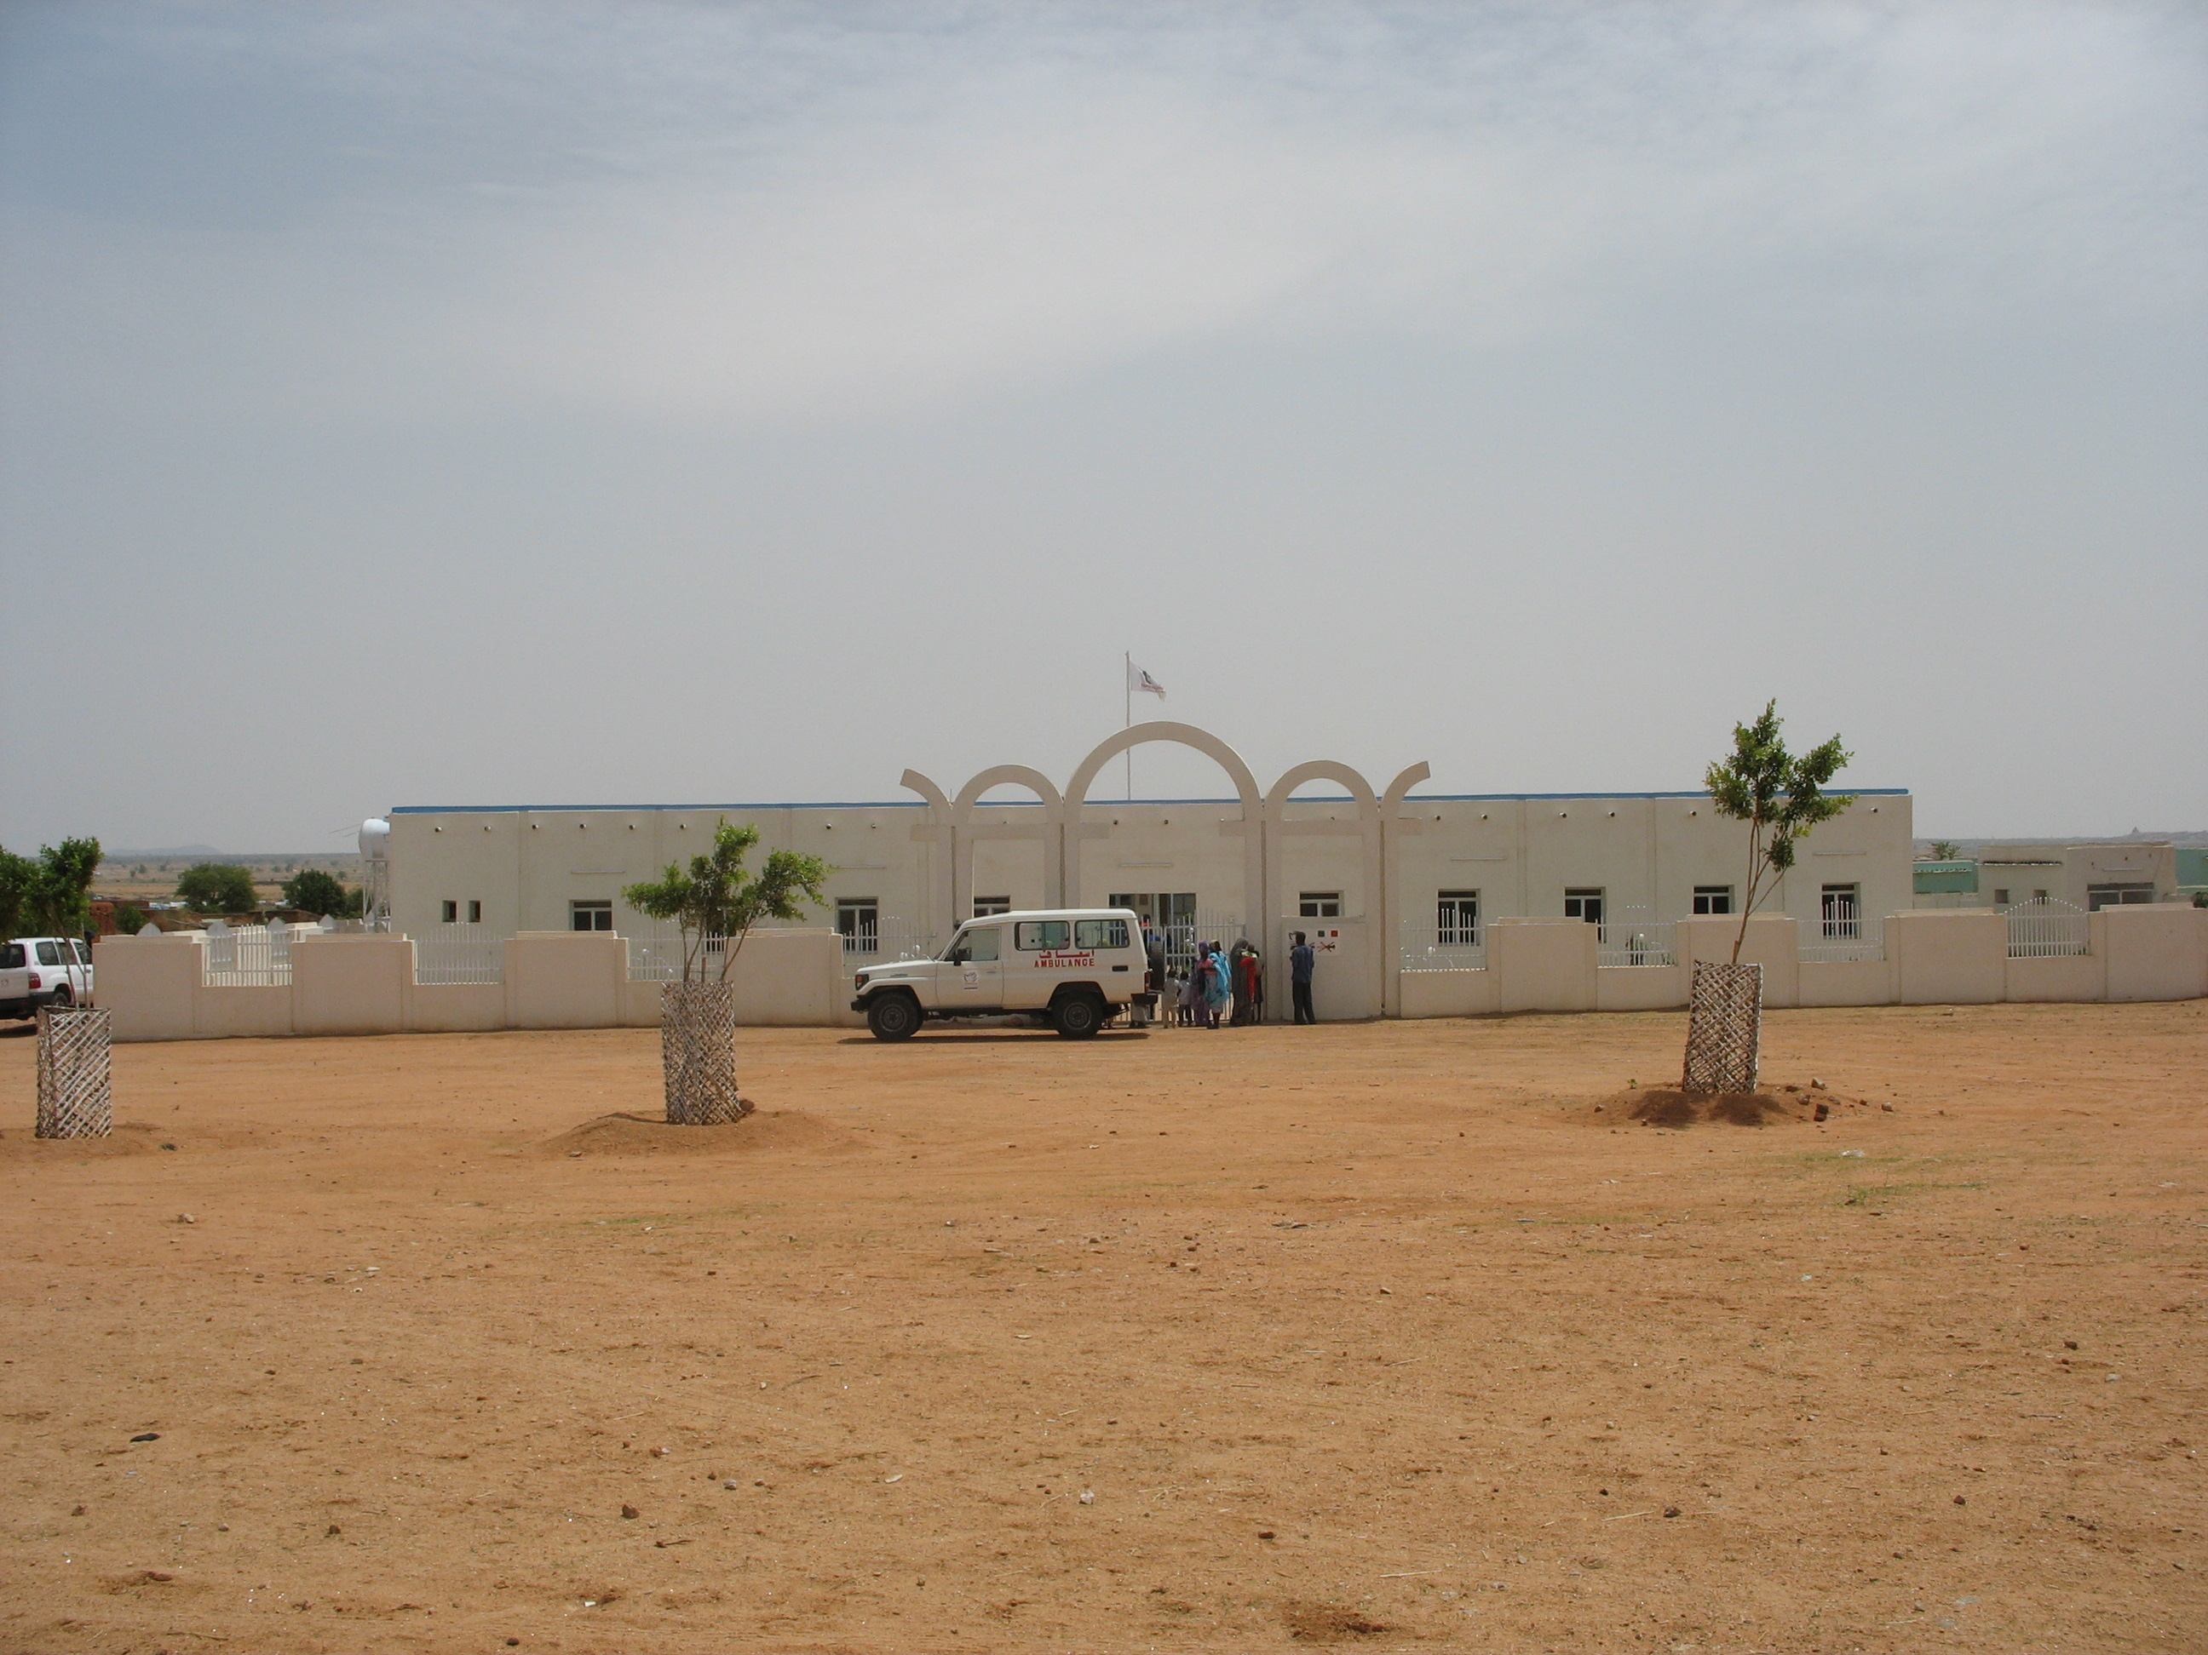
Al Jebel the Hospital before The Paediatric Emergency Center after

I was astonished because the people who seemed more proud about the hospital were the guards.
I would not have expected such a think, but this was what exactly happened.
I selected the guards from the Tariqa Al Tijani community with only one exception of one Dinka guard.
His name is Gnoc that in Dinka language means “sheep”, strange name for a Dinka warrior of 1,90 height ,well built , with scars along his face as tribal marks.
The others were taken all from the Tariqa, with one poor fellow that was a refugee from Ethiopia extremely thin, not even Sudanese but the one most careful about the hospital.
All of them proved that they were honoured by the Italian gift, and in a land where people kill each other like flies, it was very shocking to see an Ethiopian former refugee and a Dinka being so attached to this charitable institution.
They were not simply guards, like the thousand and thousand jobs that we are accustomed to see in Africa, where young boys idle all day in front of the big villas of the rich people waiting to open the gate and then close it again.
My guards were the “Guardian of the White Hospital”, the same people that strolled all the building and pretended from the poor villagers to treat it properly.
My satisfaction was to see hundreds of ladies from the nearby IDPs camps coming with their children to the Hospital and getting free access and free drugs.
The Sheik , of course, was so proud that every time was coming in Darfur, he managed to stop by the Hospital that brought the name of his religious group.
Today the Paediatric Center is still giving free services and drugs.
Almost half of the people employed have connection with the Tariqa Al Tijani, and the population that are benefiting from the services are almost as all the poor IDPs from the nearby camps of Otash, mostly from Fur tribe.

