Janjaweed
By Giorgio Trombatore

At the moment there are only two reasons for travelling to Sudan, one is for business (petrol industry, companies for services, embassies ect…) and covers most of the annual entries and the other one (despite lately is increasing) is for tourism.
Port Sudan and its beautiful sea coast ,the Pyramids of Meroe and the Cataracts of the Nile offer to the few tourists incredible landscapes.
Funny that I am here since three years , and apart one short week in Port Sudan, I never went to those location.
My working and touristic sight has been always Darfur!!!
In Darfur ,as you may understand, people travel only for the first reason, work.
Rather with the UN agencies , or government, or religious foundation, no one goes in Darfur for tourism, even thou once in the past the rich people from Khartoum used to travel to Jebel Marra or to the water-fall near Nertiti, but those time are well passed away.
Of the two locations mentioned above , one is the safe-heaven of Sudan Liberation Army (definitively not a sea –resort) and the other one is a no man’s land where Janjaweed move freely.

The Janjaweed!!!.
I know that this word often is linked with the Darfur crises, even thou the journalists of every channel (BBC, Rai, Al Jazeera) they lack pictures, films, or scenes from their attacks.
When I am in Nyala in my house , I often see on the BBC the television the same shots of films, where you see a couple of arabs in camels and far away a village that is burning.
Very little indeed for a notorious group that for more than three years is giving troubles to the guerrillas movement and as well to the government itself that seems no more able to control them.

I had myself the chance, the “honour” not only to meet them after serious clashes but to experience their fury after that in January 2005 returning back from a visit with the SLA leaders in the mountains of Jebel Marra, I came under attack with my little pick-up by a band of Janjaweed that ambushed me about 12 kms out from Kidingir road.

I still remember that day, I was in the car with another three people.
We were passing a Wadi (the bed of the river), the vegetation in Jebel Marra in January is still quite strong, like a green savana.
The road was sandy, all around no signs of life.
From Menawashi to Kidingir after the last camp of IDPs there are only abandoned villages.
They look pretty scary.
Usually they were villages of 15 huts, you could often see the rest of pots on the entrance of the hut, like if the people ran away collecting children and living their humble huts behind.
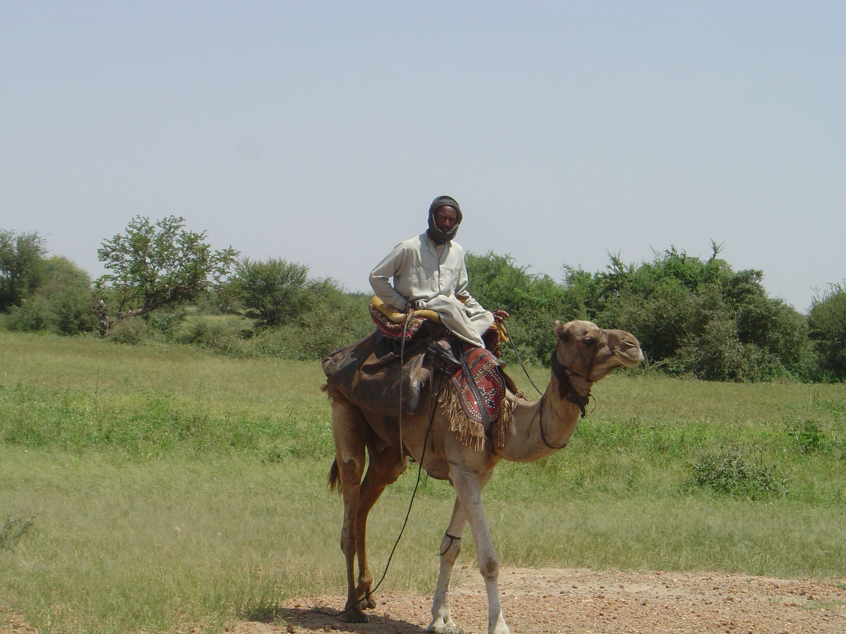
One of the Leaders of the Janjaweed on the Jebel Marra area

We had just passed one of this village, and some of us smoking, enjoying the breeze of the wind. I remember that I had a tape of the Bee- Gees playing , when suddenly a from a nearby group of trees an unnumbered group of Janjaweed some in horses and some in Camels came out fast from the trees and attacked us shooting like crazy against my little pick-up.

Everything happened so fast that our reaction I was believe was an instinctive act of self protection. As I was driving I changed the gears trying to increase speed as the bullets were falling on top of our car, likely they always miss us as I believe it should not be easy to shoot a target on top of a moving camel.
My comrades shouted back, but the Janjaweed were already out of sight, since I turned my pick-up away from their reach.
As we continued to run away toward Menawashi we met a village that was previously attacked by the same group of Janjaweed.
I did not see the bodies of anyone as the villagers crowded around my pick-up. The villagers were tense and angry, they lost some cows and people have been killed during the attack. They seemed ready to divert their rage to anyone else.
One old woman pleaded me to take his wounded son to Nyala.
I saw him , he was laying down inside a makeshift shop that sold soaps, clothes and staff like that.
The boy had three wounds for what I could see , but I had no space in my little pick-up. Finally we located the boy and the mother on the back of the pick-up.
I hoped that additional one hour drive and check-points included would have saved his life in a hospital in Nyala.

I drove back to Nyala, from time to time looking on my rear-mirror to see the boy that was ailing in the back. God bless I reached Nyala and he was still alive, but I was unprepared to face a crowded hospital where people could have died on a waiting room.
I made room myself using the “Respected presence of the Foreigner ”or the Hawaja (the white man) as people use to call white foreigners.
The doctor seemed not bother about the young boy, he asked to live the boy on the floor , and assured me that somebody would have looked after him.
I protested telling him that the boy was suffering from three shots, and one hour drive in the back of a car, and that he needed immediate help.
Finally the doctor tired of my severe presence , followed the case.
A couple days later I went searching for the mother of the boy. In the hospital they told me that the boy was out and one guy offered himself to take me to the location.

The mother after the boy was released was advised not to travel to Menawashi immediately, because the boy needed rest.
So I found them in a suburb of Nyala. The boy was located in a small room used as store-house. Having no money , the mother accepted this tiny place.
It was a dark room, very stincky, probably from rotten maize and full of rats.
I handed over some food some money to the mother and went away disgusted!.
The boy saved from a sure death was thrown back to the sad reality of a miserable existence.

After the attack of Kidingir , and since I was determined to keep going in Jebel Marra in order to assist the SLA population, we decided to meet the famous Janjaweed located in that area in order to avoid at being shot at every time our vehicle was transiting their area.
The task was not easy neither. How to ge the right Janjaweed? How to approach them? And what about our clashes where from our cars bullets were shot as well?.
I prepared myself for another trip in the area, this time with the aim of meeting the Janjaweed.

One day the opportunity presented itself unexpectedly.
I was on a regular mission toward Fena- Kidingir for meeting SLA population, when on the side of the Uadi, I saw many arab nomads with their camels moving on the opposite side.
I ordered to stop my vehicle , and decided the approach!!!.

It was group of Rezegat with their cattle.
They were moving toward Kass in order to find water for their animals. I knew they were the same group that in the past attacked me.
I looked for the guy who seemed the chief.
He confirmed that he knew us and that was familiar with our vehicle.
He did so speaking directly from the camel, not even getting down.
I told him that I wanted to visit his camp, to exchange some talks with him, so finally he accepted.
I left my vehicle nearby a Uadi then I proceeded with them. Walking for another half a kilo, they, the arabs, following me with their camels.
I could spot on the their rifles, and some of them had as well swords, like the one that you see so often in the border with Eritrea, where Rashaida and other tribes walk along with beautiful swords.
\
When I reached their camp, the ladies came out immediately from the tents.
They all wore the red dresses typical among their tribe, and as well the hair was combed in a particular way not familiar among Fur tribe.
With me there was a doctor, so I proposed that children should be checked.

Tea was soon served , now the mood was relaxed, they accepted my presence.
They knew I was the Hawaja (the white man) that crossed every week their territory in order to bring aid to the SLA rebels, but now I was in the tent with them, not an enemy but a guest.
A guest is untouchable in the nomads belief, no matter who is the guest. On top of that my doctor was so busy to visit children, that soon the news arrived in nearby camps.

Once the elders were all around me complained that they were left behind by the government and as well complained attacks from SLA.
“Funny” I thought exactly the same comment from the rebel side.
The Janjaweed were telling me that they were no safe anymore, and that in order to prevent cattle theft or attacks from SLA people, they had to fight for their existence.
I stayed with them until sunset, then I headed back toward Nyala.
The truce hold for a couple of months, until my vehicle came again under shots.
New groups settled in the area.
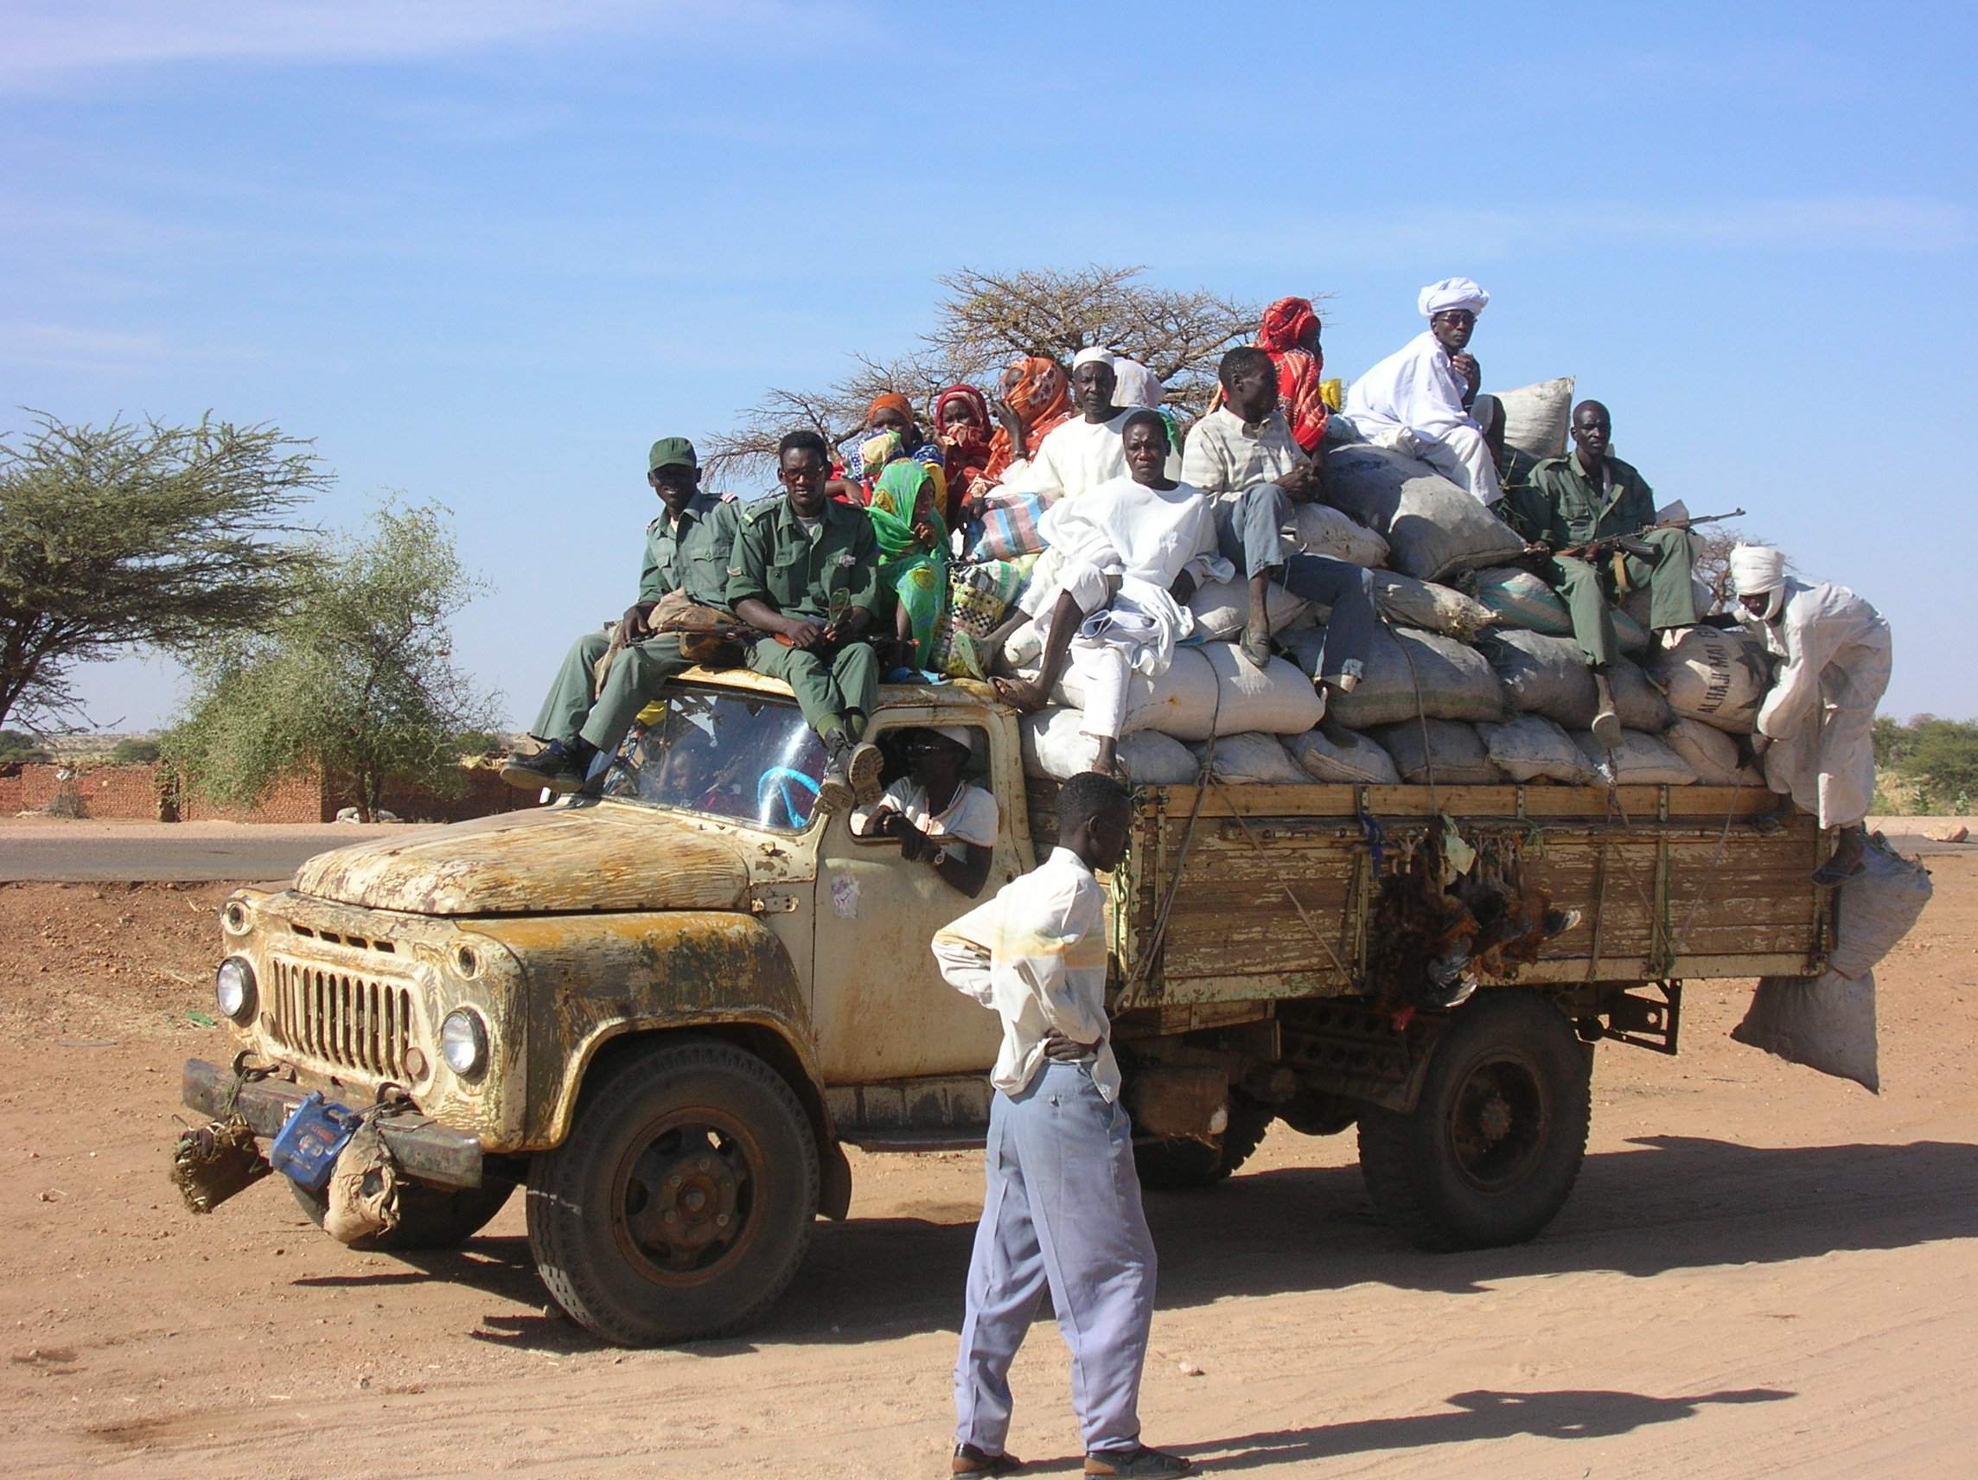

Again, the problem of transport.

I had always one constant problem in working in Darfur, and that is reaching vulnerable population under rebels group.
Usually the rebels are located in the interior where roads are bad, river flow easily obstacles any kind of passage even for days.
But most of all the banditry activity and Janjaweed make the trip more difficult and sometimes lethal.
Regular trucks have always militia on top to persuade attackers, but this does not work anymore.
Some areas are so dangerous that even African Union came under attack, despite their armament!!!.
So here comes the problem, how do I reach the location with all these difficulties.
Sat-Phone is one way of solving it.
The guerrilla usually once they are informed they patrol the area until they feel safe. They wait me with their pick-up overloaded of young rasta soldiers, usually with a browining type model on top of it.
For the Janjaweed it is like betting in the casino.
You may have worked out a truce with a local commander, but the possibility that new groups move in the area is always to be taken into consideration.
The good thing is that usually these Arabs militia prefer to assault WFP trucks, one reason is for preventing food to be deployed to SLA or Jem areas.
Actually when I say good I mean that I am out of that particular target.
The Government itself in order to put an end to this often organized big escort transportation.
I witnessed myself on the road from Kass – Zalinje – Genena, big trucks full of all sort of commodities and on each side government troops.
Janjaweeds hardly attack Government escorts, because they know that fighting would be not easy. The Government troops are ready to respond, instead African Union even thou they are well equipped, brand new pick-ups refrain from answering to fire, and the possibility to get attacked is much more higher.

The Janjaweed Assaults as told by villagers in Singita
It is also interesting the way the Janjaweed conduct their assaults.
But this time I do not refer as the one that myself was a victim with my vehicle on the way back from Jebel Marra, but as referred by one village farmer in a place nearby the town of Kass.
I am talking about the notorious Singita village located on the Kass-Guba axis, in the south west of Kass. It is about half-hour from Kass, and the condition of the road is mainly sand, it can be quite muddy during raining season.
With a small population of 1575 persons mainly from Fur and Tarjam tribes, witnessed several attacks from the Janjaweed.
The population of this village as I said is composed by Fur tribe mainly peasants, meanwhile the Tarjam have got as well animals (horses, donkeys, sheep).
When I visited this village (that can be taken as an example for history and happening to many others in Darfur)the security situation was still an issue.
The Janjaweed militias attacked and destroyed the village down to ashes for two times.
Killing as many as thirty people. The people following the second attack escaped in nearby town Kass (before 40,000 residents, now almost 80,000 with the IDPs) for security and shelter.
But Mohammad Halil remained , and told me that he saw both the attacks.
He said one early morning they woke up due to the cries and screams of the families that lived in the huts nearby the Uadi.
Several Janjaweed in horses and camels were shouting and killing people, giving to fire their huts.
He took his family in the bush and could not prevent the Janjaweed from burning his hut and robbing his goat.
After the attack was over some men of the village immediately tried to persecute the attackers, but the Janjaweed positioned some of their men nearby stones waiting for the response of the village.
They were pretty much the snipers of the militia and shot down any attempt by this farmer community to respond .
It seemed to me a pretty well organized group.
As Mohammad talked he sipped his hot tea.
The government promised some more police, he said, and I spotted a couple of police forces in the entrance of the village.
But Mohammd cries out that the population of his village they still fear other attacks and they prefer to remain as IDPs in the overwhelmed Kass town.
He lost a family member , and seems not to understand this war.
He says we are all Muslims, it is not like south and north, why this war?
Not much help has arrived in this village, and on their second attack the janjaweed destroyed also the crop, and stole all the animals.
The same situation you can feel it in the nearby Guba, where meanwhile I was talking to the Scheich a group of Janjaweed passed by the village and the people taking the chance that myself was present, indicated me the Arabs and said :” look you are here, go and tell what you are seeing”.
I did not know what were the intentions of those 10 Arabs riding their camels near Guba , but having experienced so many horrors I understood their fear.

