Monday, September 25, 2006

The bottom of the humanity, by Giorgio Trombatore
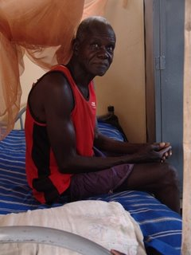
Celso is the last man of the world.
When I met him , I thought that the desperation,
the hardship of his life, made him the last one in this earth.
The first time I saw him, was in a hut located in Taiba a suburb of Nyala. He shared the hut with the rest of his family, a Christian family originally from Waw, from the Balanda tribe, that for several reasons ended up their life in the war torn Darfur.
He, a black man from the south Sudan, caught in the middle of the Darfur fighting between arabs and black muslims, was left aside , living on the mercy of few people, and on the poor salary of his wife Elisabeth.
Elisabeth was working with the Sisters of Charity in Nyala, from early morning to evening . Every day Elisabeth knew meanwhile was heading back home from work,that an old drunk man with rheumatism was waiting in her hut.
In the same hut, in a small filthy and smelly room there was their little daughter Veronica forced to live in a bed since birth for brain problem.
The air was always smelly of urine, since the old Celso had no strength for himself to move. The little daughter was left always by her own, strangled in her bed with dystrophic muscle diseases and brain damage.
There he was standing Celso, uttering few words that I hardly comprehended, he was staring these foreigners people (mainly Italians , and the sisters of charity) that from time to time walked in their hut and cleaned the poor Veronica in order to avoid that urine and dirty could provoke her more trouble.
An Italian woman, about a year ago, touched by the sorrow of this family, bought them a small land, where a humble house was constructed.
A year later, I visited the house, Celso was in a room under a bed , hardly moving from his rheumatism, Veronika in front of him in bed , with her smile not moving.
The place was much better than the previous hut, more dignity, even thou you could sense the desperation in this house.
Another small house was built where kitchen was located and an additional room. A open toilet outside, a surrounding wall and a gate.
This new house is located not far from the previous hut, but it is their now.
The sister of Elisabeth after loosing her husband killed by the Janjaweed joined the family with a small orphan. The family grows bigger so the hardships.
Life does not stop, Celso is there standing in front of her suffering daughter , on the wall an image of crucified Christ, on his face is written , that the humanity has reached his bottom on this man, and every time I visit him , I can not look too long on him because I feel painful, like a stinger in my heart, a sense of revolt and distress toward my existence.
This is tough scenery and I can not get it out of my head.
Giorgio Trombatore

